# Assignment 2

**Name(s): Dushyant Singh Udawat, Pratikshit Singh**

**NetID(s): ds35, ps71**

In each the following parts, you should insert the following:

* Train/test loss plots
* Qualitative outputs for GT, No encoding, Basic Positional Encoding, and Fourier Feature Encoding at three different scales

**Part 1: Low resolution example - SGD**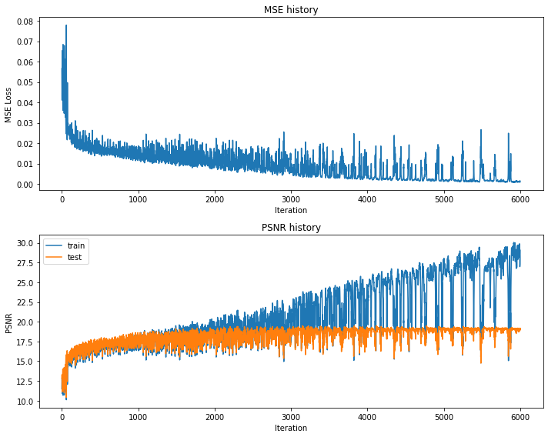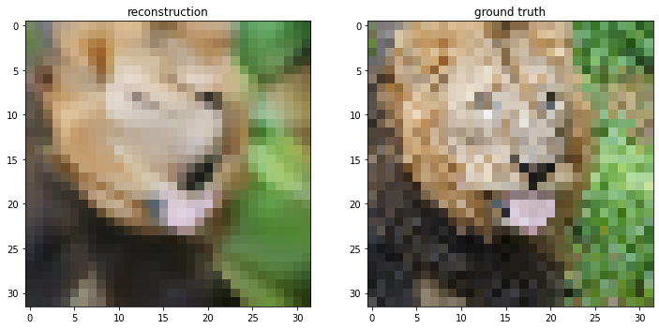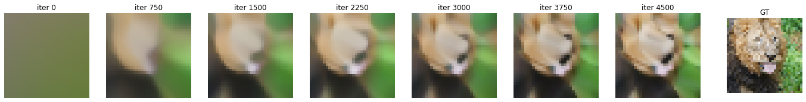

**Now after trying all the different encodings (SGD optimizers)-**

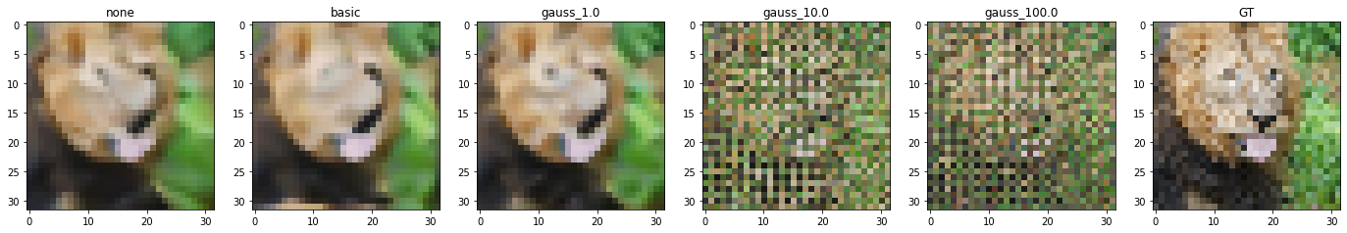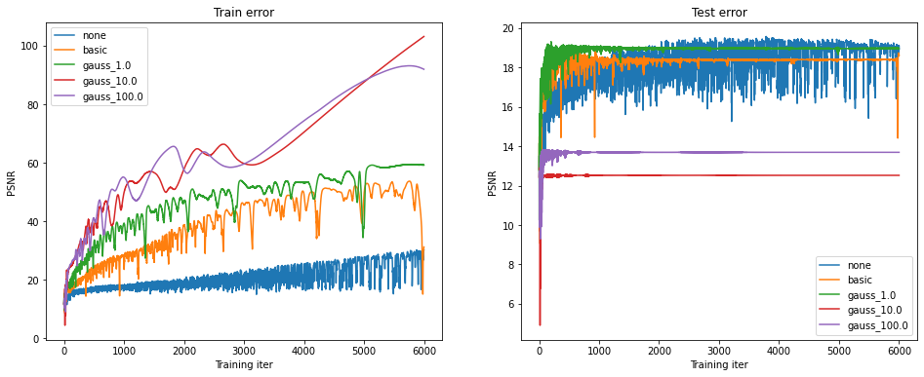

**Part 2: Low resolution example - Adam**

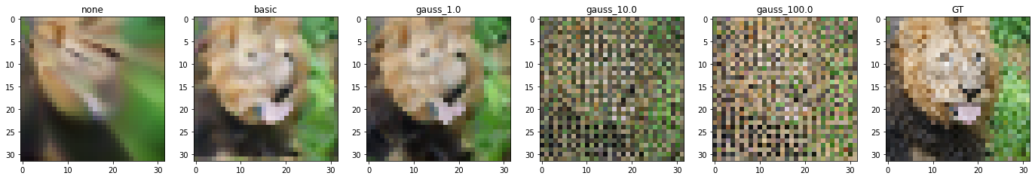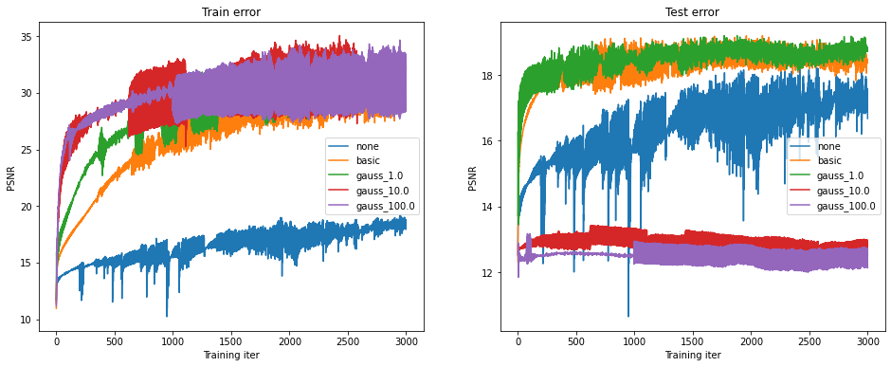

**Part 3: High resolution example**

**(We did it using SGD Optimizer)**

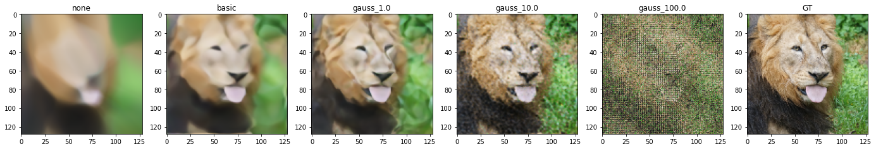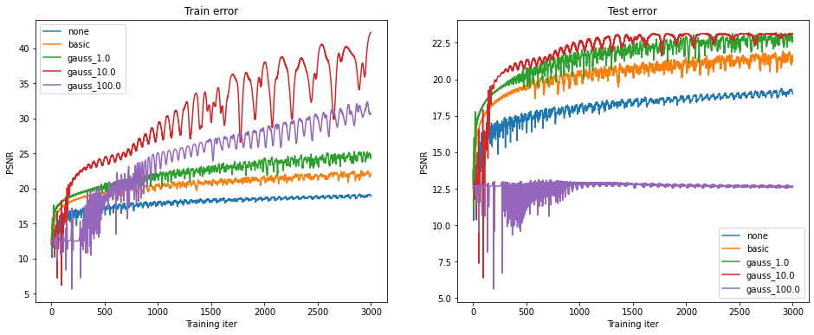

**Gaussian 10.0 is the best mapping.**

**Part 4: High resolution (image of your choice)**

*(For this part, you can select an image of your choosing and show the performance of your model with the best hyperparameter settings and mapping functions from Part 3. You do not need to show results for all of the mapping functions.)*

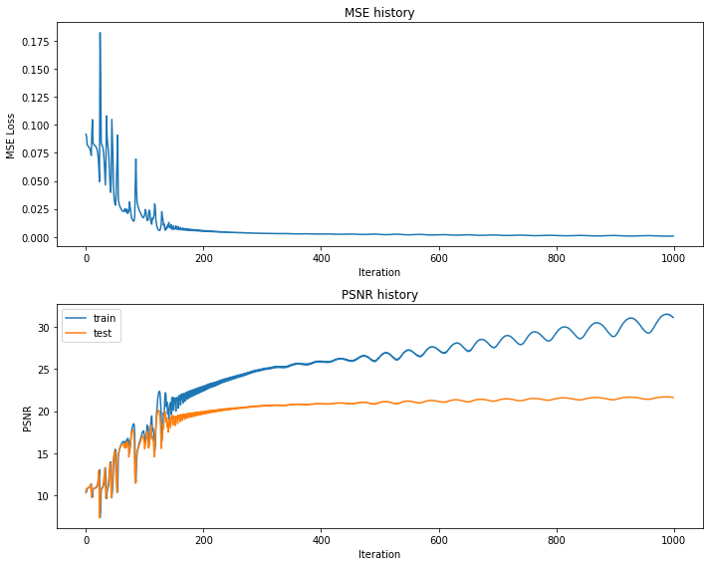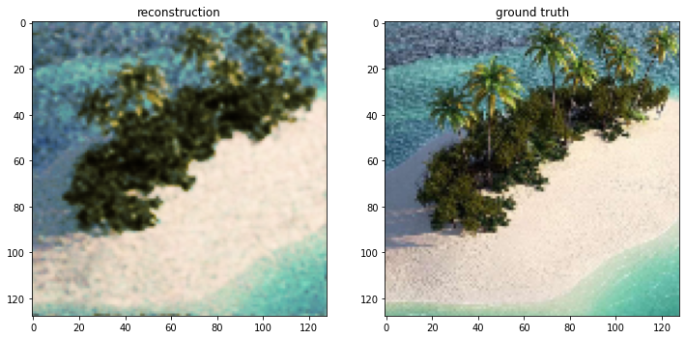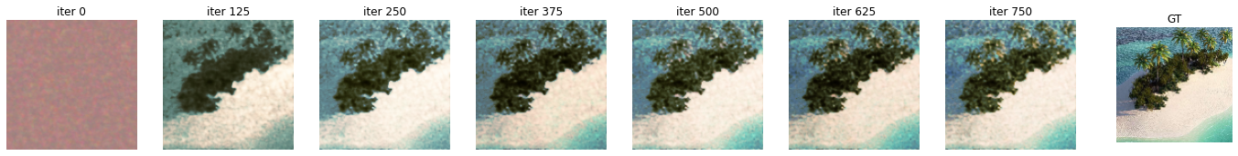

**Part 5: Discussion**

What hyperparameters did you apply ?

***We tried different hyperparameters -***

1. ***Learning rate SGD - 1e-1, 1 , 10(best)***
2. ***Learning rate Adam - 1e-3 (best), 1e-4***
3. ***HIdden Sizes -*** 
   1. ***[64, 128, 128, 128],***
   2. ***[64, 128, 128, 128, 64],***
   3. ***[64, 128, 128, 64, 64] (Best)***
   4. ***[512, 1024, 512]***
4. ***B1 and b2 for adam - [0.9, 0.999](best), [0.99, 0.999]***

***We did try these hyperparameters at least once, but not all combinations of them. In all, we did run the models for about 10 hrs.***

*How did the performance of SGD and Adam compare?*

***In our case , SGD performed better, Adam had some serious limitations, the accuracy of test set started decreasing after 2000 epochs. The reason for that is the setting of parameters b1 and b2 in adam , it seems the weightage given to momentum was a little too high. We did try tuning it but then the accuracy wouldn’t even compare to SGD. So, We chose SGD in the end for high resolution image.***

*How did the different choices for coordinate mappings functions compare?*

***In low resolution, it is gaussian 1.0 that performs best. In high resolution, gaussian 10.0 performs best. This is because, gaussian noise allows for more dimensions and the more the noise the greater the separation between inputs features (scalewise) (Kind of Similar to Kernel trick). Their has to be a specific optimal paramter , which is 1 for low resolution and higher at 10 for high resolution.***

*What insights did you gain from your own image example (Part 4)?*

1. **Gaussian noise with sigma 1 performs great and is giving expected outputs.**
2. **The training is actually quicker that the original image, I believe the reason is that the image is more homogeneous than the lion image.**
3. **The tree leaves are the most fuzzy part of the image because of their high variation in color patterns.**